Chapter 19, Solution 78

For h₁₁ and h₂₁, short-circuit the output port and let I₁ = 1A. 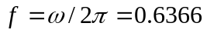. The schematic is shown below. When it is saved and run, the output file contains the following:

FREQ IM(V_PRINT1)IP(V_PRINT1)

6.366E-01 1.202E+00 1.463E+02

FREQ VM($N_0003) VP($N_0003)

6.366E-01 3.771E+00 -1.350E+02

From the output file, we obtain

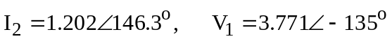

so that

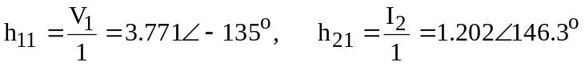

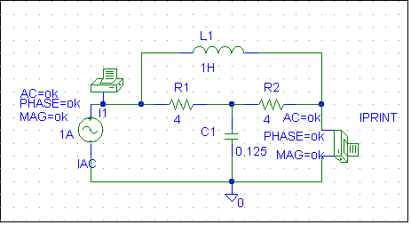

For h₁₂ and h₂₂, open-circuit the input port and let V₂ = 1V. The schematic is shown below. When it is saved and run, the output file includes:

FREQ VM($N_0003) VP($N_0003)

6.366E-01 1.202E+00 -3.369E+01

FREQ IM(V_PRINT1)IP(V_PRINT1)

6.366E-01 3.727E-01 -1.534E+02

From the output file, we obtain

so that

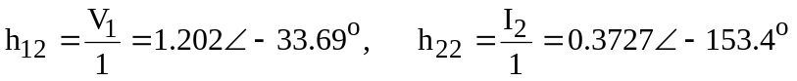

Thus,

